

MUSIC MP3

Listen your adorable song with Music MP3

**Team members:**

U1610075 Ibrat Abidov

U1610078 Ilkhom Rakhimov

U1610092 Jamoliddinkhuja Odilkhujaev

U1610120 Anora Kosimova

U1610148 Mokhlaroyim Tuychibaeva

Github link: https://github.com/iuthub/design-project-music-mp3

Website: http://89.236.217.5:6607/ip.loc1/ip.loc/

Table of contents

|  |
| --- |
|  |
| About company …...................................................................................................................3 |
| Main functions of the website......................................................................................................3 |
| Website in details……...…................................................................................................4 |
| Main page description………………………….........................................................................5 |
| Header description…………………………...............................................................................6 |
| Body description……………………………….........................................................................7 |
| Footer description……………………………............................................................................9 |

Genre page description…………………………………………………………....…...………10

About page……………………………………………………………………………………..12

Sign in page………………………...…………………………………………………………..13

Admin page………………………………………………………..…………………………..17

Admin Message page………………………………………...………………………………..19

Admin Suggest page………………………………………………………………..…………..20

Music Add page………………………………………………………………………………..23

Users page…………………………………………………………………………………...….24

Profile page……………………………………………………………………………………..24

About company

This is the website is dedicated for true music lovers. Today, there are dozens of websites with musical contents there but unfortunately, not each of it has content with a high quality. Namely, songs that are frequently searched are not to listen online. Before directly downloading the song, in order not to spend memory, more logically will be to listen to the music online. Nowadays, internet usage is getting more and more popular, so enjoying the music by listening online will not make any problem.

Main functions of the website

Here visitor can listen to favorite music, as well as share with his/her friends in chats and groups. Whatever song visitor looks for, he/she can easily type and search. All newly released songs can be found in the website. Moreover, all of them are sorted according to the genre. User can press “like” button in order to save particular song in his/her favorites list.

Starting from websites main page, every single design is according to comfort usage of the user. Songs are sorted according to the popularity and freshness. Website automatically generates and puts most liked songs in “popular” list.

All website functionality is quite easy to manage. In this report, every single functionality will be described in more details, provided with screenshots and descriptions.

Website in details

After team decided to make music website, many aspects were discussed to provide the user comfort. First job was to make attractive design.

The design of the website can either make or break the company’s business. It actually makes a difference on how the target audience views the business or company and potentially turn them into customers. As such, developing a website design that has an impressive user interface will result in a much better conversion rate, which leads to better business and revenue.

Therefore, first job is to make excellent design of the website. Today, there are many platforms to build creative website design. The platform we choose was figma.com.

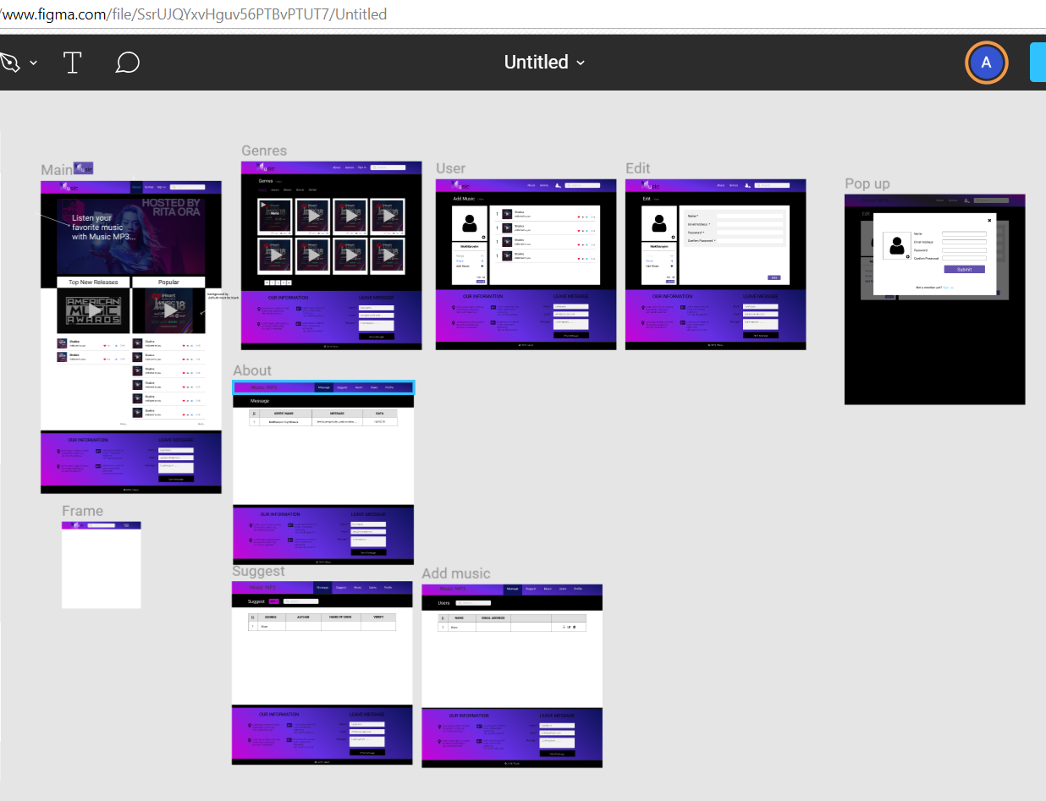

Here is the design of all pages. Every single button and blocks design is drawn, starting from main page, until popup. Further, every page in details will be described.

<https://www.figma.com/file/SsrUJQYxvHguv56PTBvPTUT7/Untitled>

Main page description

On the main page, there can be seen navigation, two blocks in body part and footer.

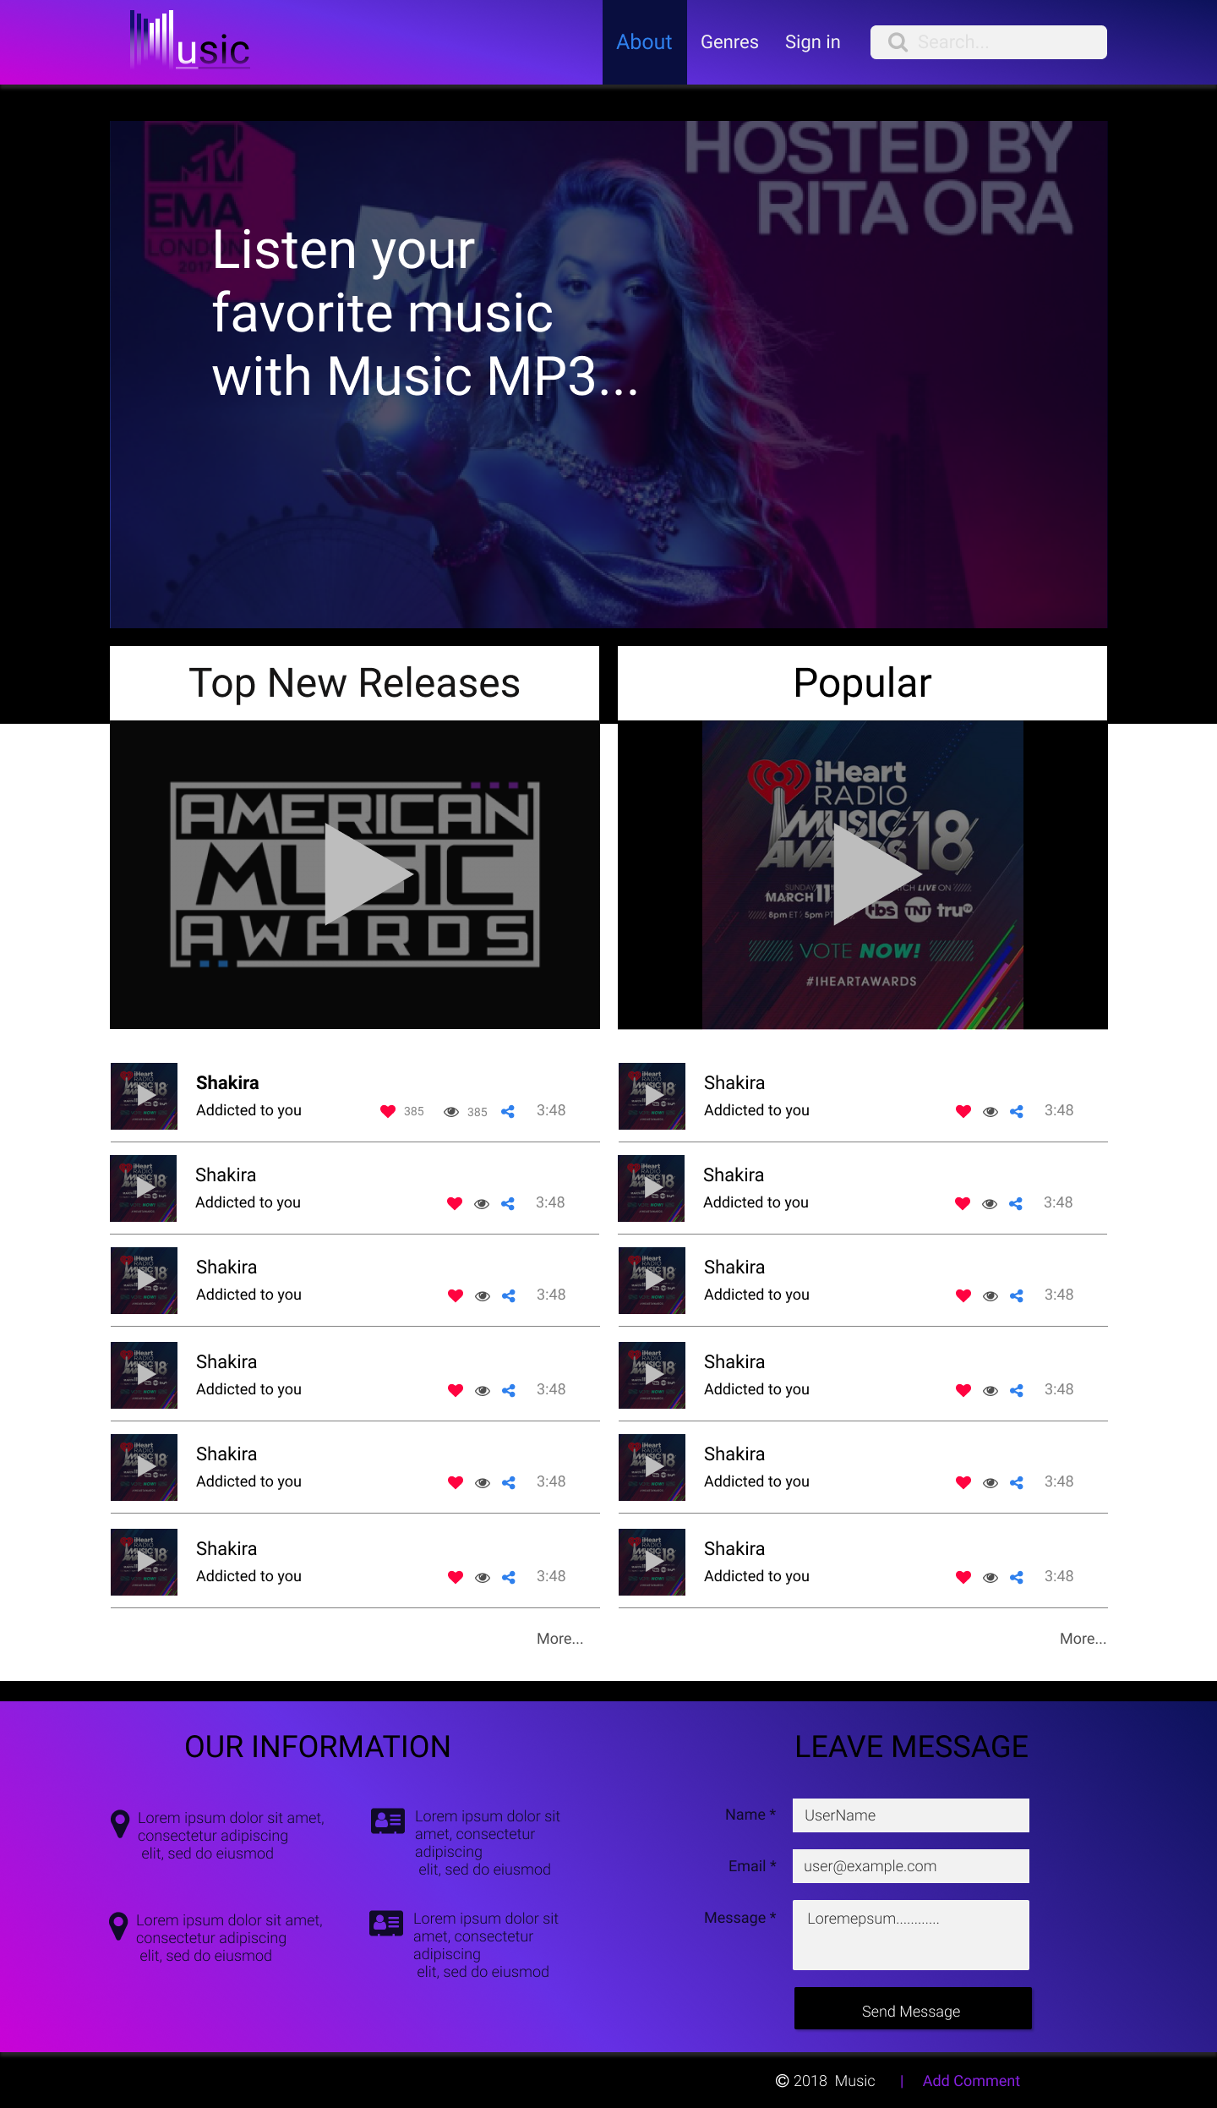

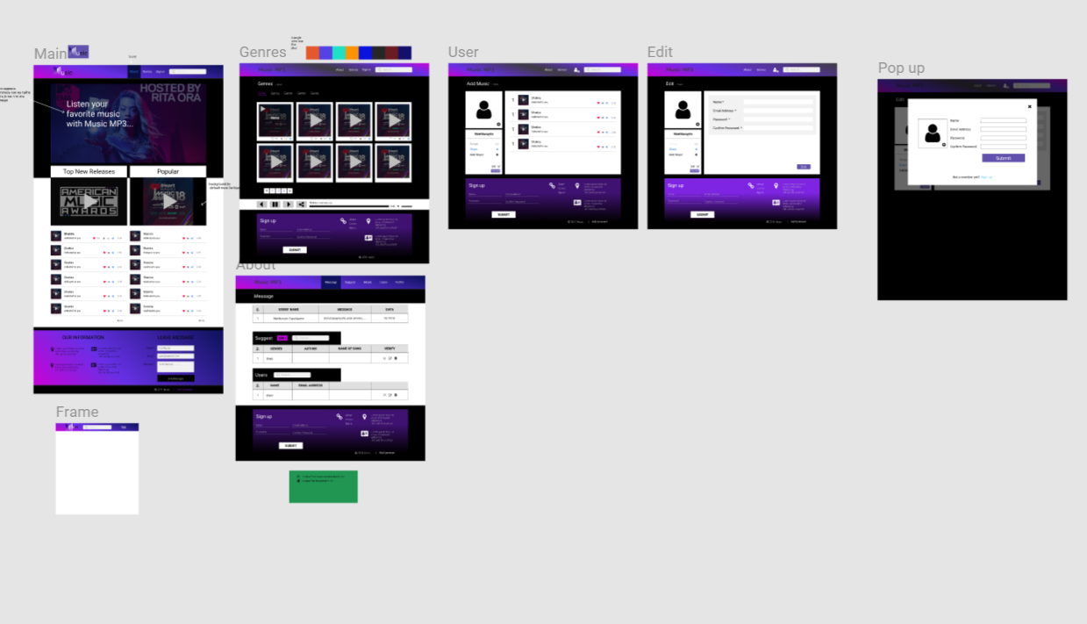Header description



Header part is made using bootstrap and css styles. It can be seen that gradient is applied.

Header contains search and links to other pages. Basically, by clicking the logo user is taken to main page. Next three links are for Genres, About and Sign in pages respectively.

One of the features of the header part is that it is adaptive.



I.e. while screen is zoomed, header part smoothly transforms to mobile version. Which means, three links for other pages will be in menu bar. This is made using JavaScript and jQuery.

When menu bar is clicked, it pops content where Genres, About and Sign in links are listed.

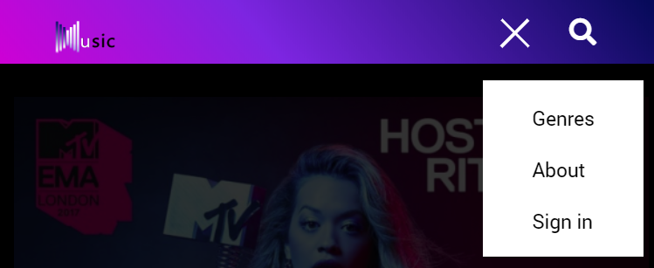

Another feature is that header is fixed on the top of the screen, even while scrolling.

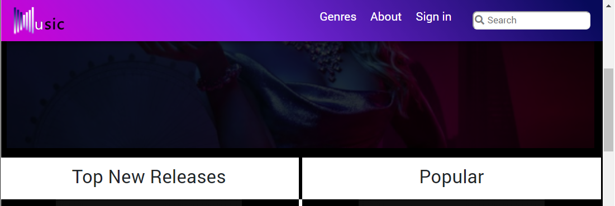

Main page body part



In body part, first background image and text typing effect on it can be seen.

The text typing effect type’s website is LOGO and then, after deleting letter by letter, types genres. This is one of the features, that makes website attractive and unique.

Next, comes two blocks. Top new release and Popular. List of fresh and recently released songs is published in former. While list of most popular and most loved songs is published in latter. Website is updated and enriched with new releases every day. Moreover, you can also like the songs that you prefer most, and after signing up, they will occur in your favorite list.

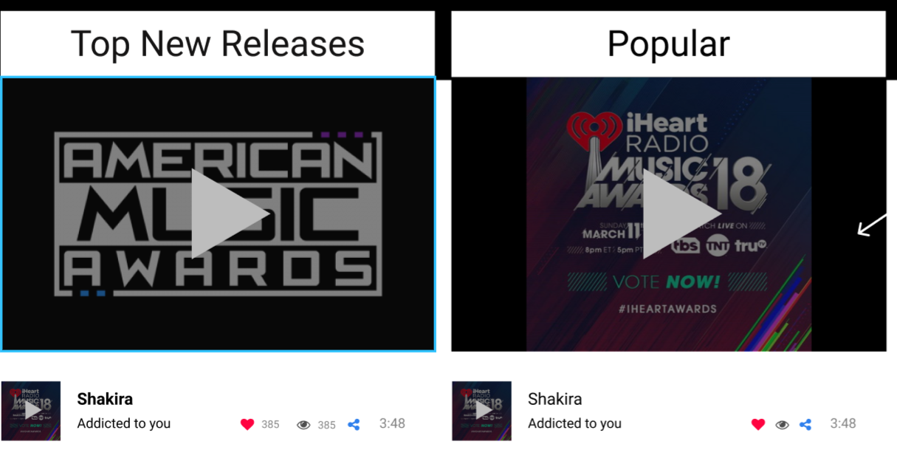

In the bottom there is information about song (artist and song name) is given.

Moreover, there are:

- like button (when pressed get red colored)

-view number (how many times song was viewed)

-share button



Footer description

Footer part is also designed using gradient in styles.

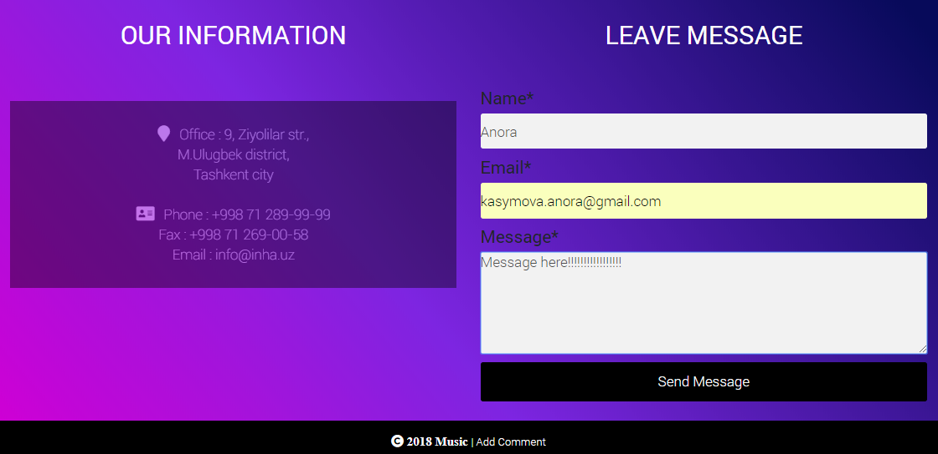

Consists of two blocks:

-Our information

-Leave message

In the first one basic address, phone and mail information is given.

In the second one, leaving message window is placed.

User fills the blanks with information and as soon as Send Message button is pressed, all the data that was entered will be send to ADMIN.

Company also has admin page, and its description will be given further.

**Implementation of backend for this page**

This page uses MainPageContreller.php

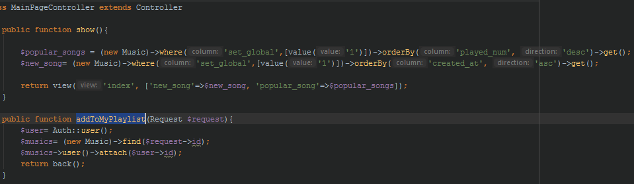

This controller contains to functions one of them is to show the index page with newly added songs and popular ones. Function show get form database using ELOQUENT and send selected data to index.blade.php,

Function addToMyPlaylist get request from client as id of song and attach it to the users playlist while user press button in shape of hart.

Genres page description

Genres page – here all songs are sorted respectively according to the genres. There are big variety of genres – starting from classical music until hard rock. Overall, for people who adore and relax with the music our website is invaluable source to find and listen.

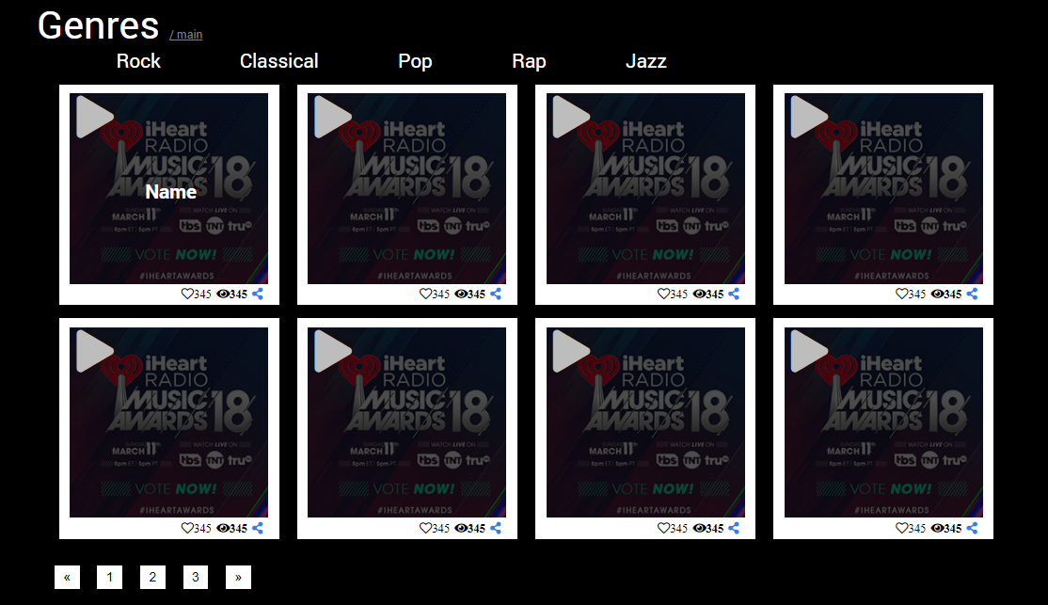

Regarding features, there are music boxes on the page. User can press button PLAY and listen to the music.

Songs are in Genre column in Data Base, and when clicked to particular genre, songs are sorted automatically.

In the center of music-box song info is given.

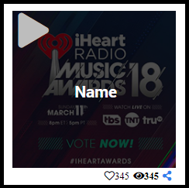 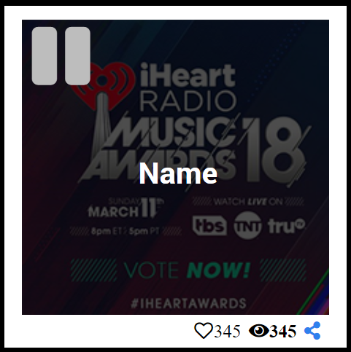

When the music is playing, it can pe pause using Pause botton which will occur instead of play button.

The next comfortable feature is that this page is adaptive as well.

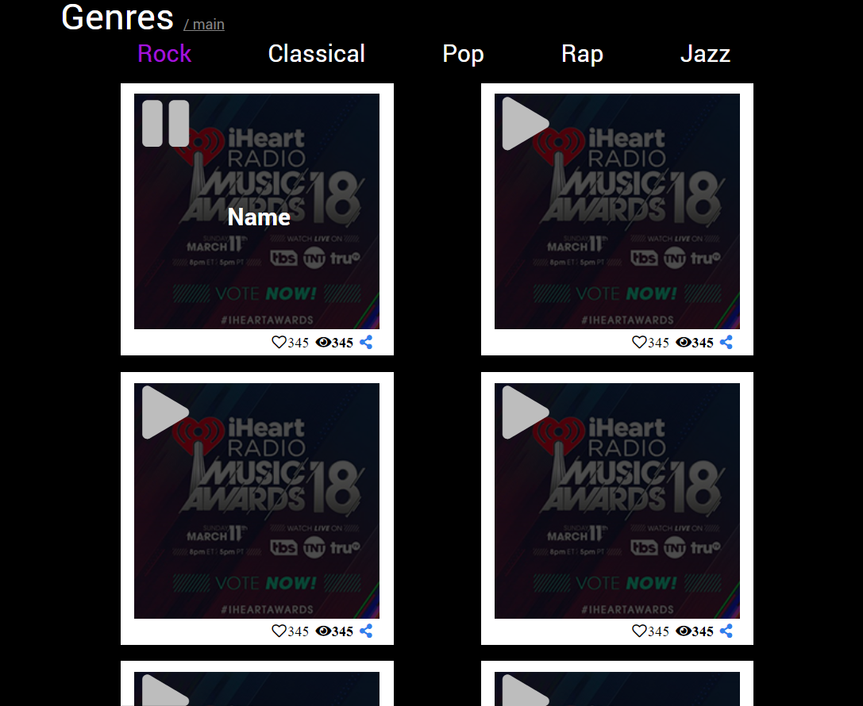

By two columns

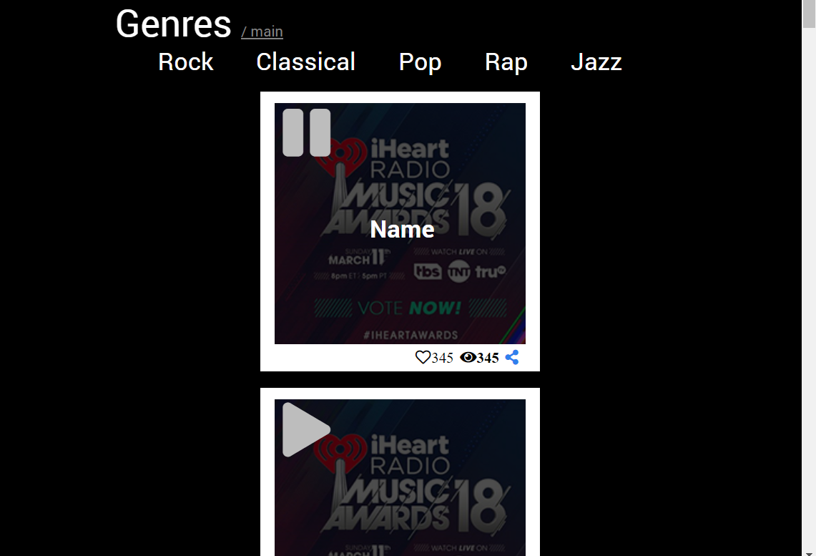

By one column

**Implementation of backend for this page**

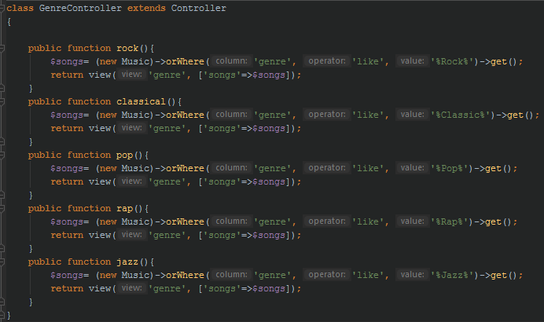

This page show sorted songs by genres. It gets all songse where column genre contains key word

About page

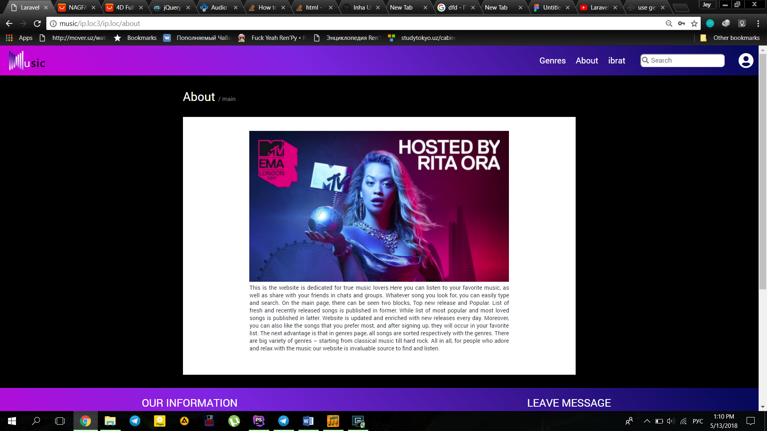

About page contains general information about the website.

It is somewhat basic about page, including image and block of content.

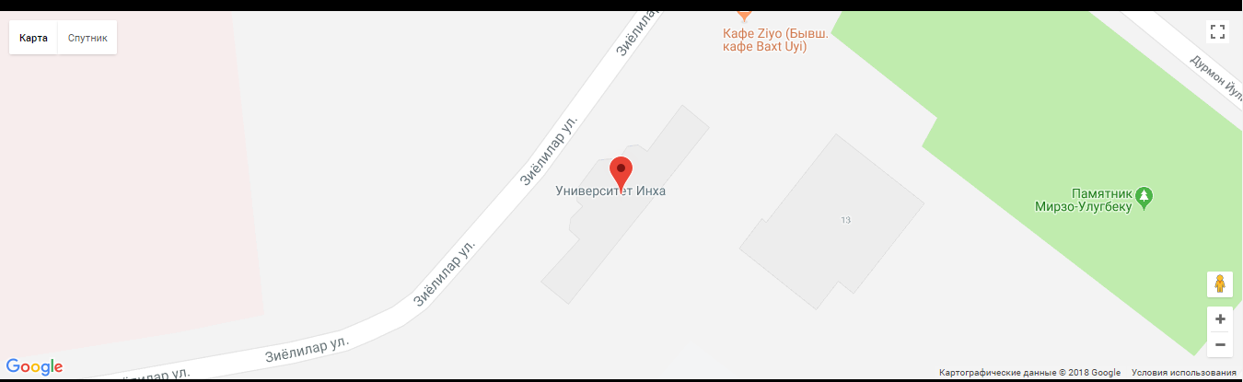

Besides that, we have implemented API of google maps, which will show, how to get to Inha University in Tashkent, our office.

Sign in

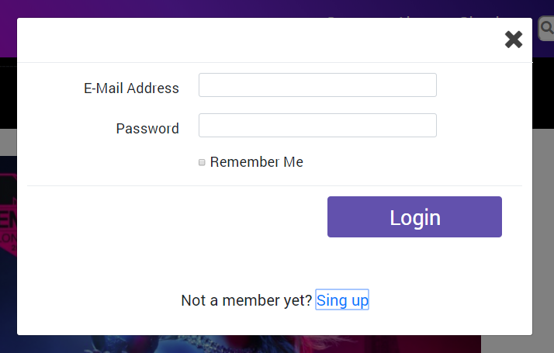

As user clicks to Sign in link, pop up occurs and here how it looks like.

If not registered, then go to Sign up page.

Sign in and Sign up pop ups, created by Bootstrap 4 modal plugins

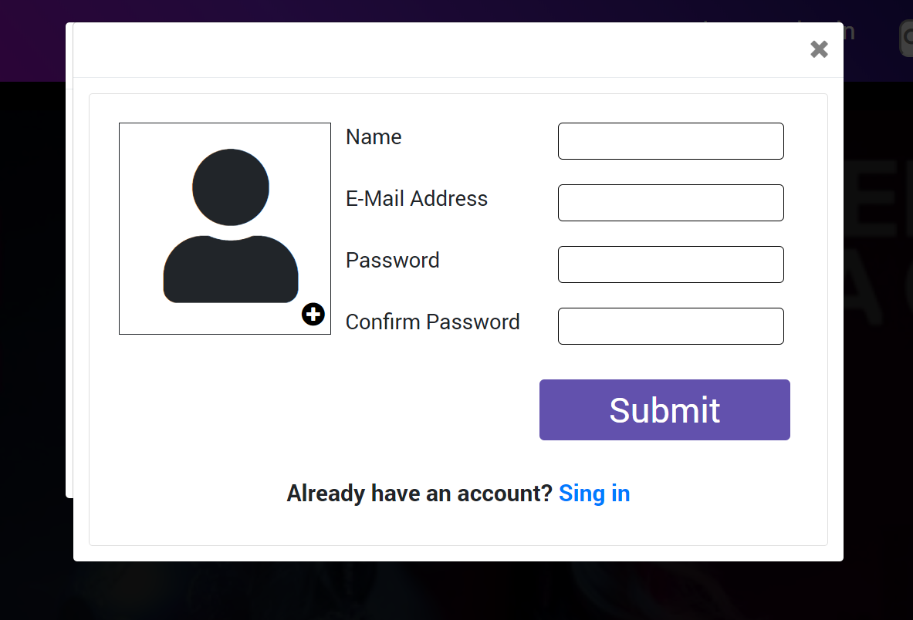

In addition, we have implemented login and register pages separately in pages.

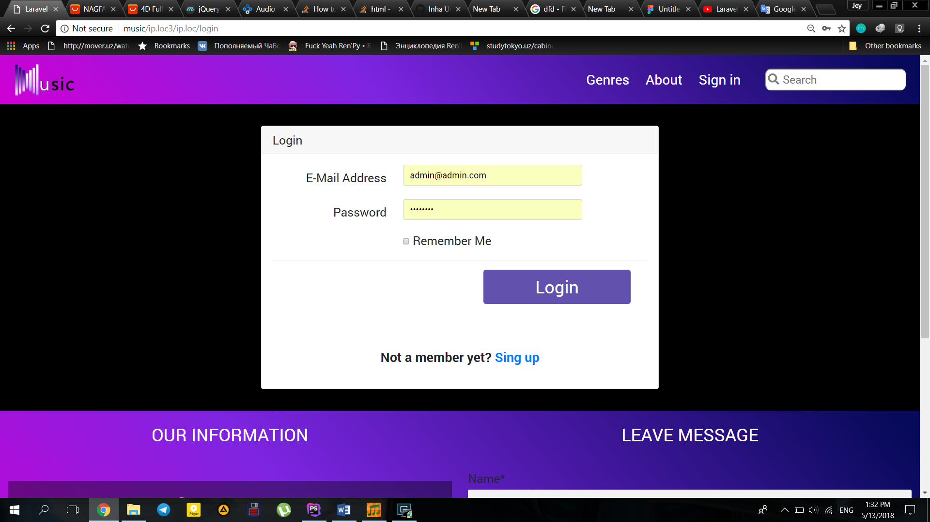

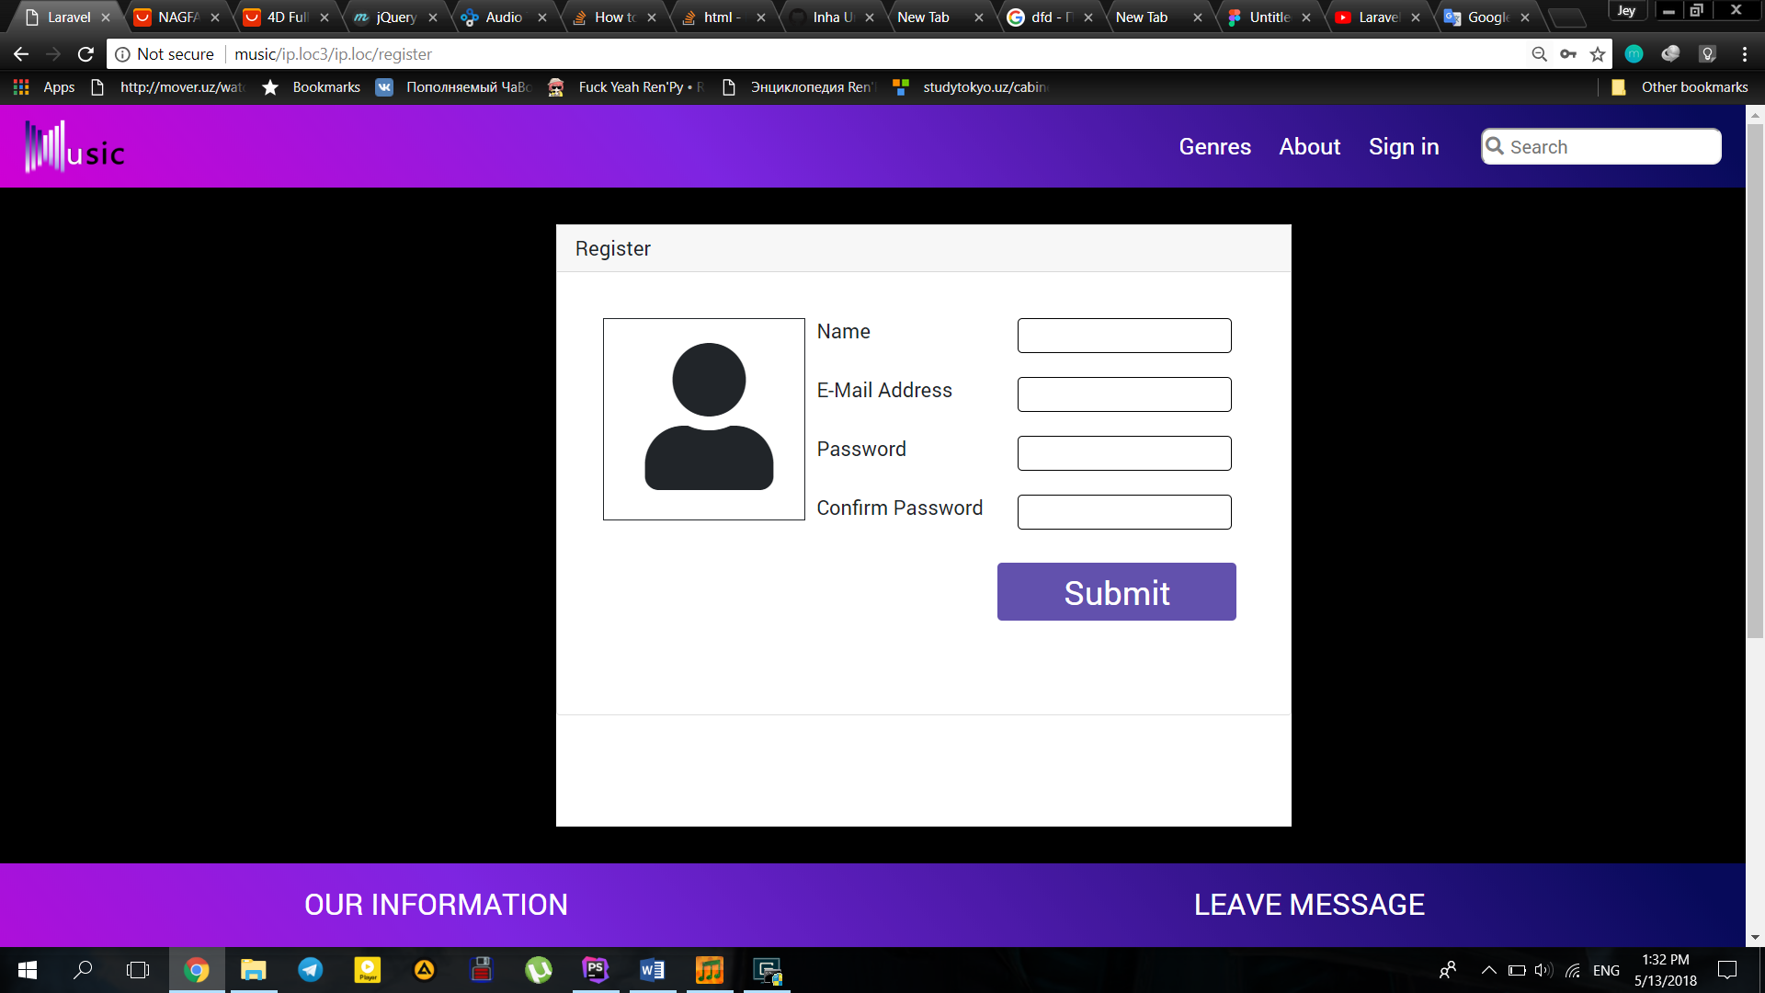

So, if unauthorized user is accessing some pages as a guest, he will be automatically redirected to the login page.

**Implementation of backend for this page**

The functionality of this part has been created using Laravel pre-installed plugins, view for this page is located in view/auth, as model and controller which are as well located at app directory.

All data is validated on client side as well as on server side

Client-side validation

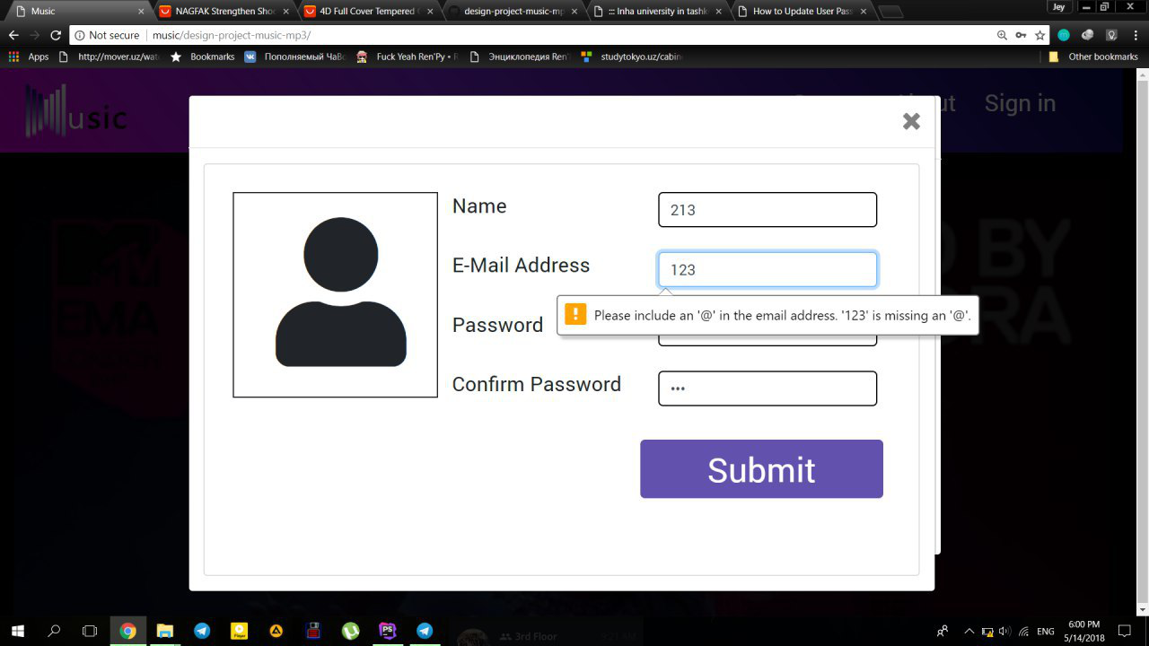

Server-side validation

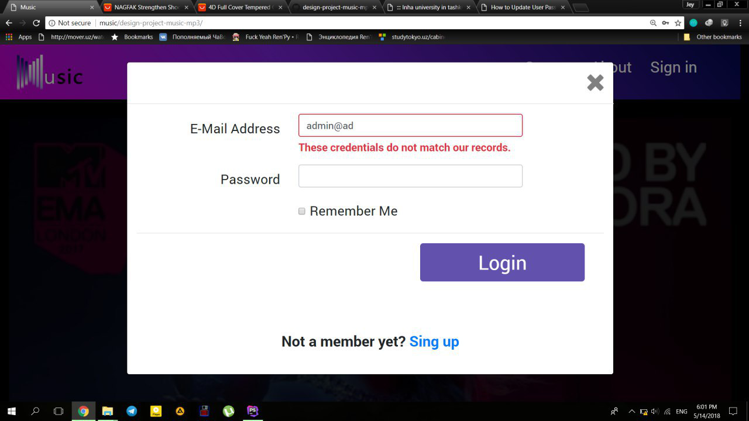

After signing in, user is taken to his/her profile page

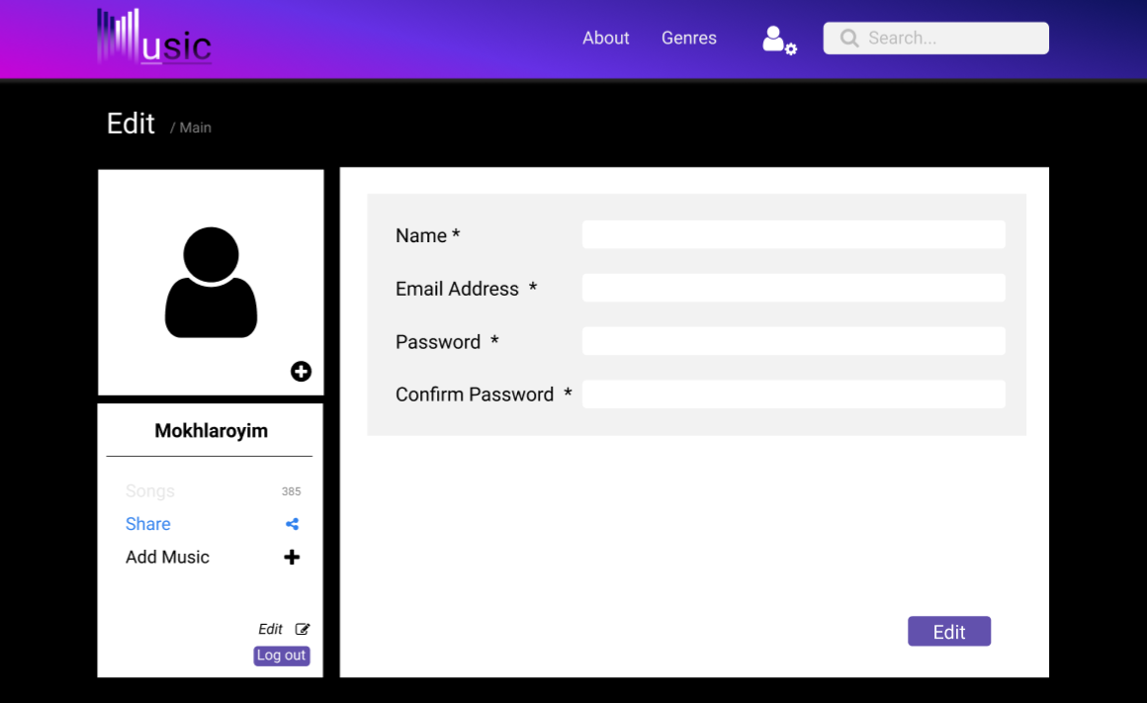

On this page user is able to see his profile, change settings, such as Name, Email address, password.

Next page is, playlist page.

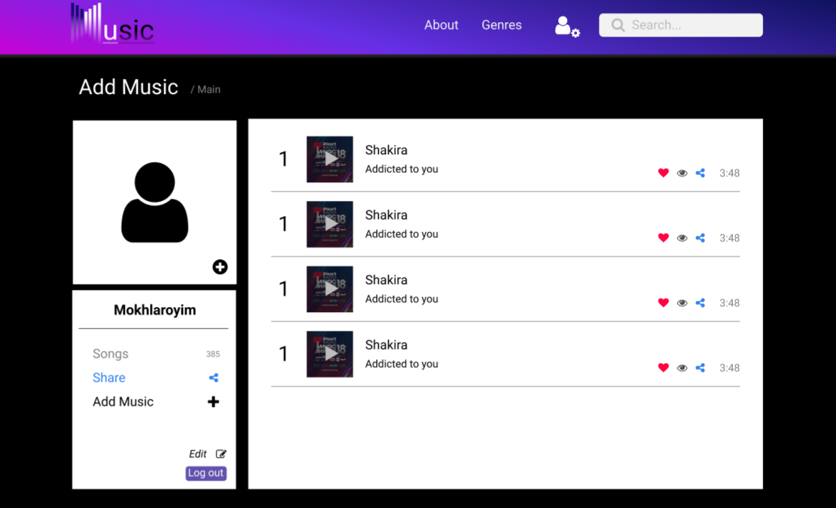

Here user sees all songs that he/she liked, namely the user’s playlist is given. Moreover, user can add to his playlist any music he wants, this song will be seen only through his profile playlist, beside it user can share this song to the global site, where everyone can see it, only after allowance from moderator or admin.

Also

Songs are played by clicking play button. As soon as play button is clicked, player shows up.

**User Page Implementation:**

User page uses Usercontroller.php

Which works with all fuctionalities in this page

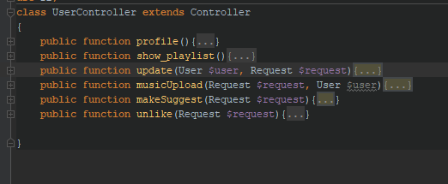

These functions were implemented on this page

For the make suggest and unlike functions we use **Ajax.**

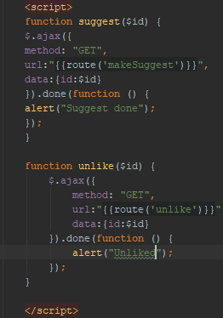

This one send id of a song to our function and then it will do some action depending what buttons user pressed

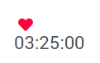

This is two buttons first can unlike second suggest to other users by sending it to moderator(Admin)

Our function also Upload song get Song special tags from song which is called ID3

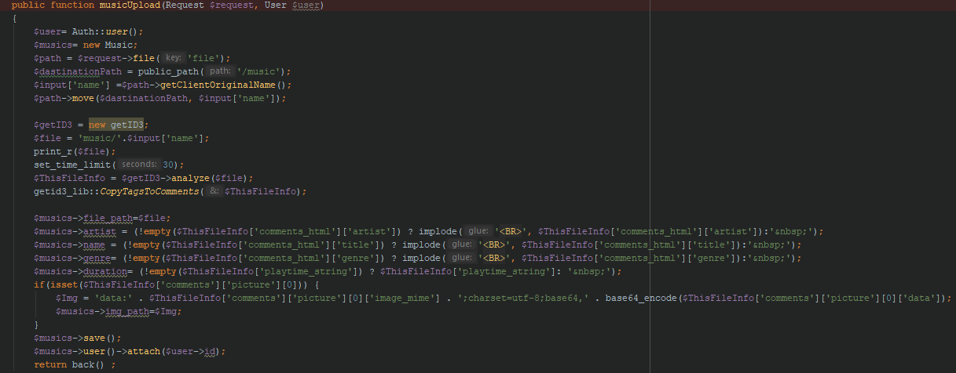

Admin Page description

In Admin Panel there is header with links Message, Music, Users and Profile.

1. Message page contains data about all sent messages from the block in the footer. As it was mentioned before, the comments and messages will come directly to the Message table.

Table consists of 4 columns:

-Number of messages (in order);

-User’s name;

-Message;

-Data (User’s e-mail).

**Implementation of functions in page Suggests.**

For this page we have several controllers in a folder Admin

We create roles using Laravel standard Autofiction and by creating relation table role_user which maps roles to users. Identifying this we did admin panel

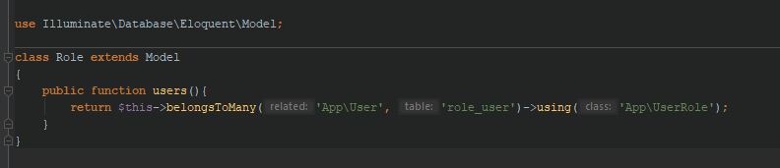

**Creating model for relations**

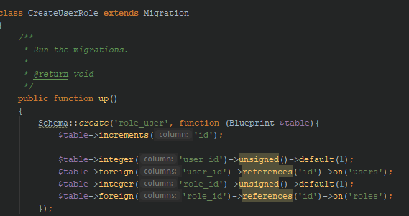

**migrations**

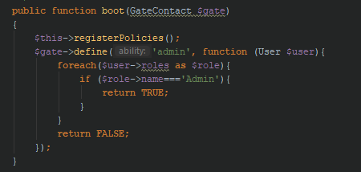

Also create function which identify the role of user in AuthServiceProvider.php

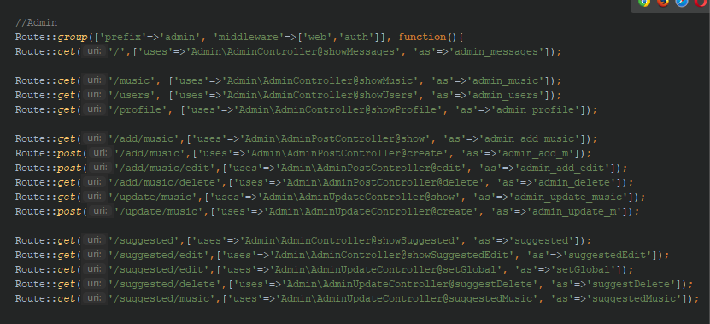

Create Admin group routs

**Admin message**

.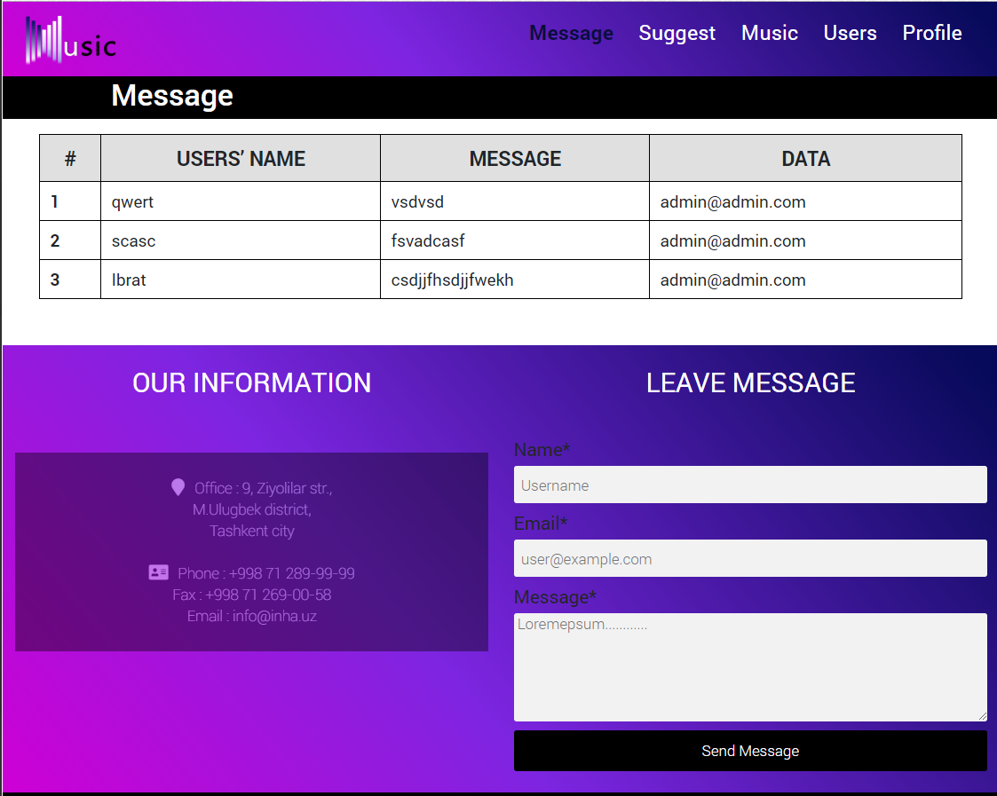

Whenever the message is sent, after refreshing the page if occurs in the message table.

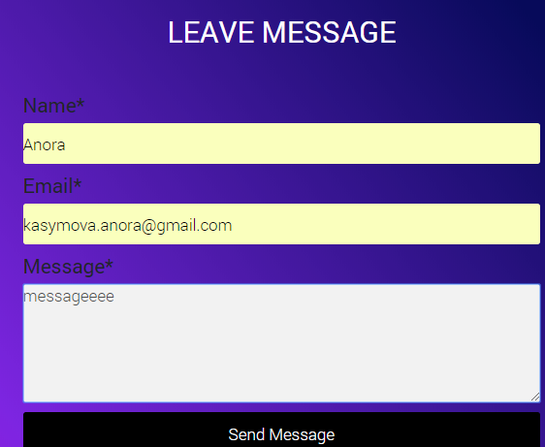

Now we refresh, and check.

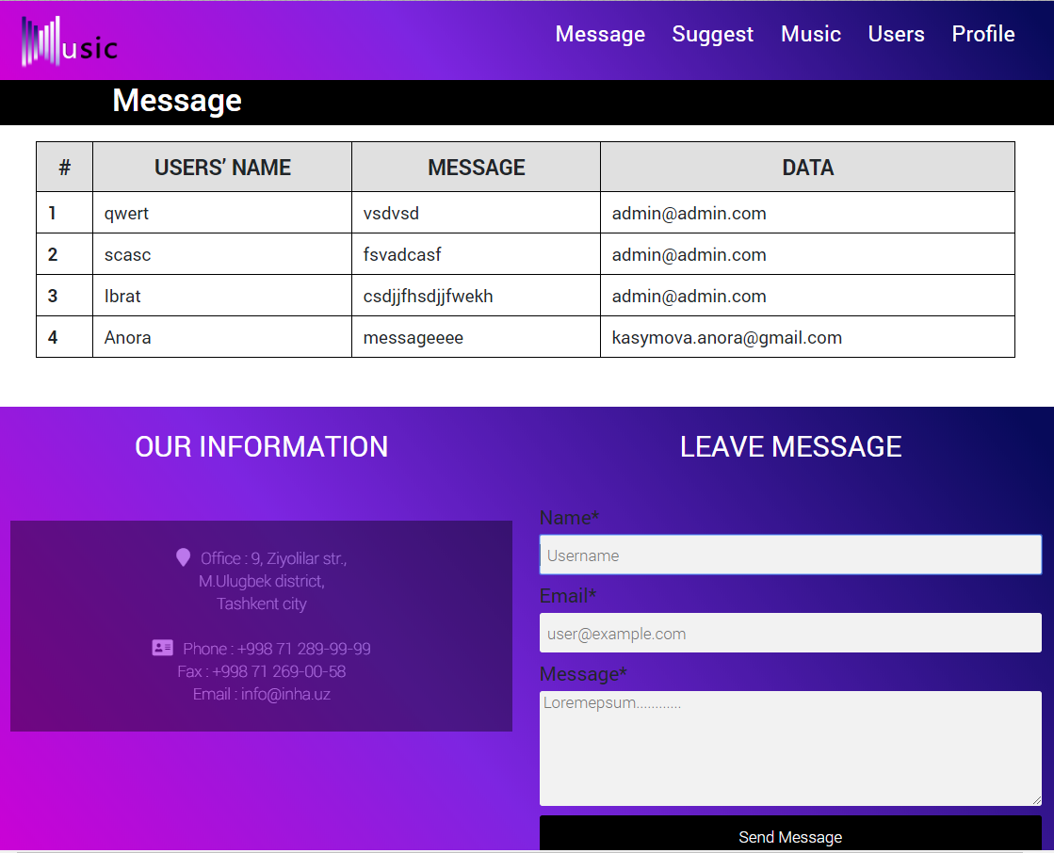

Suggest page

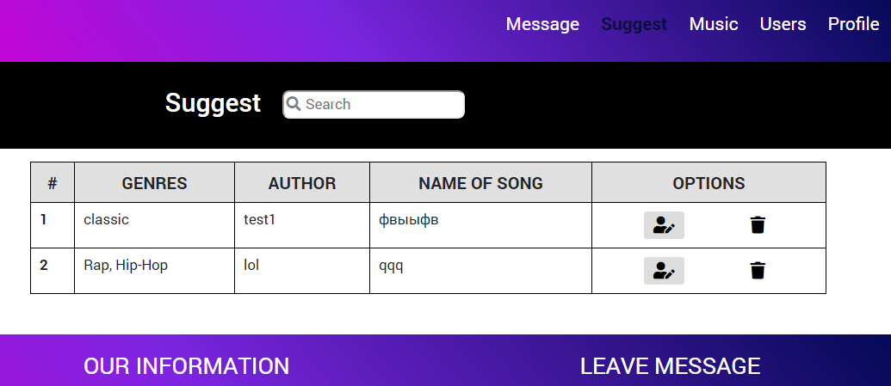

Suggest page shows table of songs, which were uploaded by users, but did not occur in the website playlist. If users wants the music to be in the website, not only in his profile playlist, he/she should suggest the music.

After suggest button is pressed, the music with its detail in admin’s suggest table.

Table consists of 5 columns:

-number of suggestions (in order);

-Genres;

-Author;

-Name of song;

-Options;

Column options has 2 functions: when first is clicked, pop-up to edit song info occurs. Admin checks all info of suggested song and then puts a tick if every detail is correct, then after pressing Confirm button; suggested song by the user will be added to website playlist.

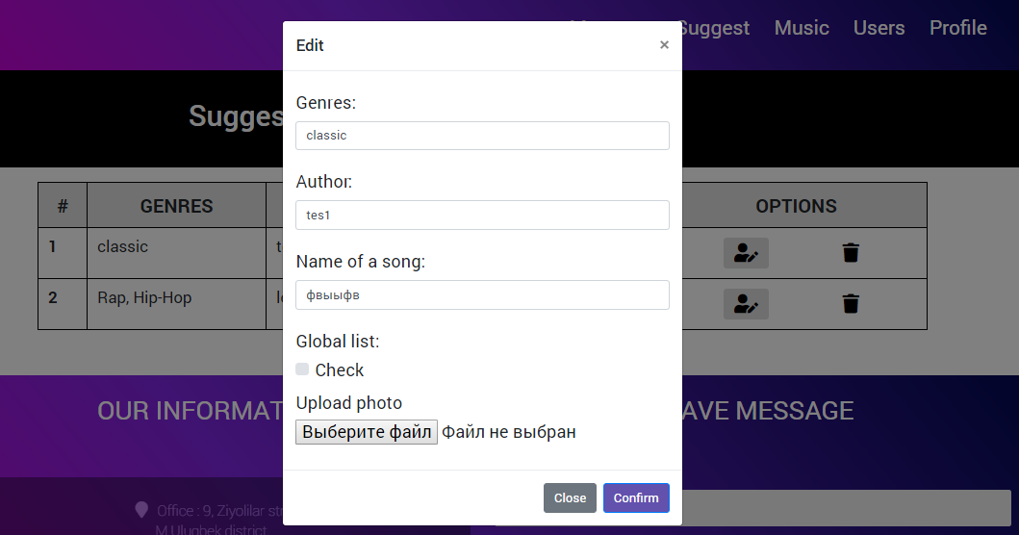

The second button is delete button. I.e. if user finds the suggested song improper, deletion is done by pressing the button.

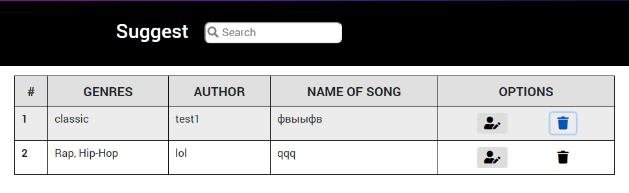

After deletion of suggestions, table’s size decreases.

**Implementation**

Edit song

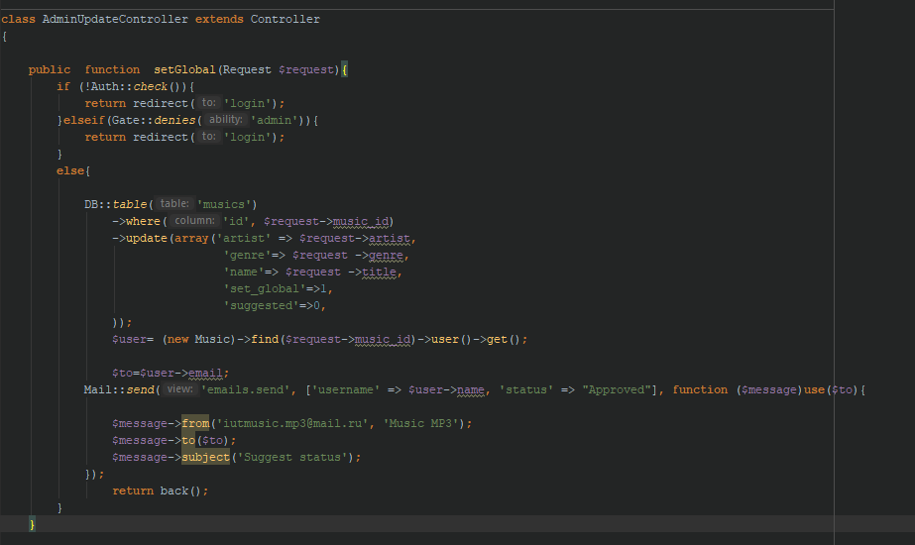

**Delete song (Reject suggestion)**

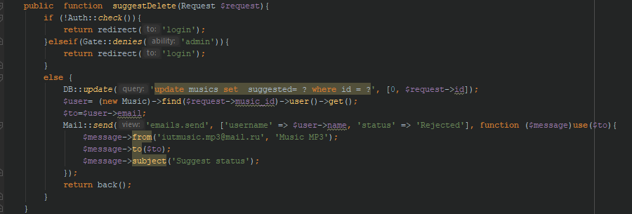

These functions can notify user what decision has made moderator

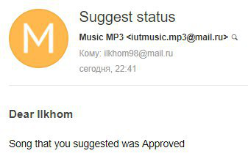

All pop-up on this page also implement **Jquery**  and  **Ajax Admin/suggests.blade.php**

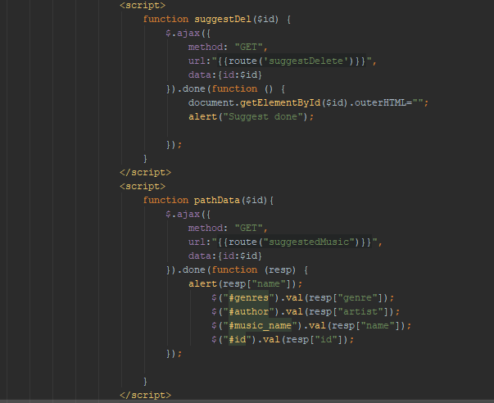

Music add page

The next is Music add page, from where admin can add, edit or delete songs.

Want to note that this is set of global songs which can be reached without registration all other private songs of users cannot be seen here. Only After being proved or added by moderator can be find in this llist

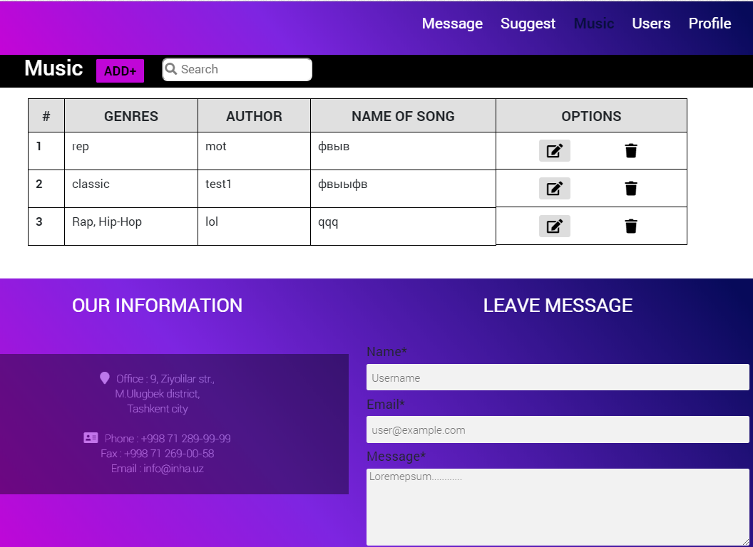

**Implementation**

The implementation is the same as in suggest however it can add songs using the function in user playlist upload.

Users Page

User’s page has table where all registered users are listed including Name and e-mail address.

As an option, admin can delete user from the database of website.

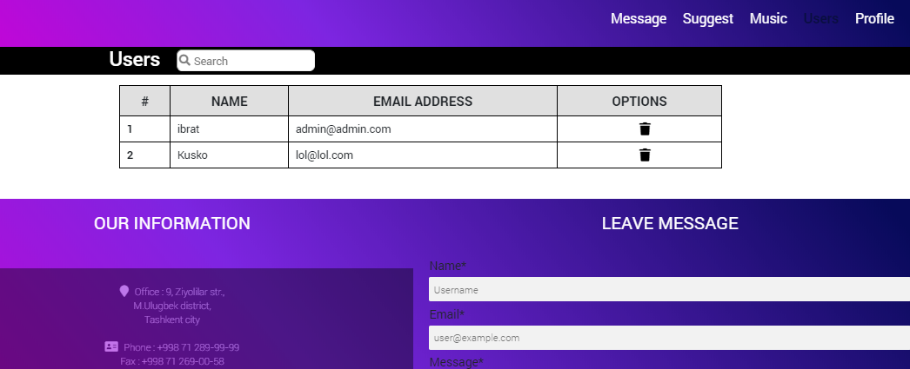

Profile Page

This page is for editing admin’s profile.

Admin can change his name, email address, and also change password

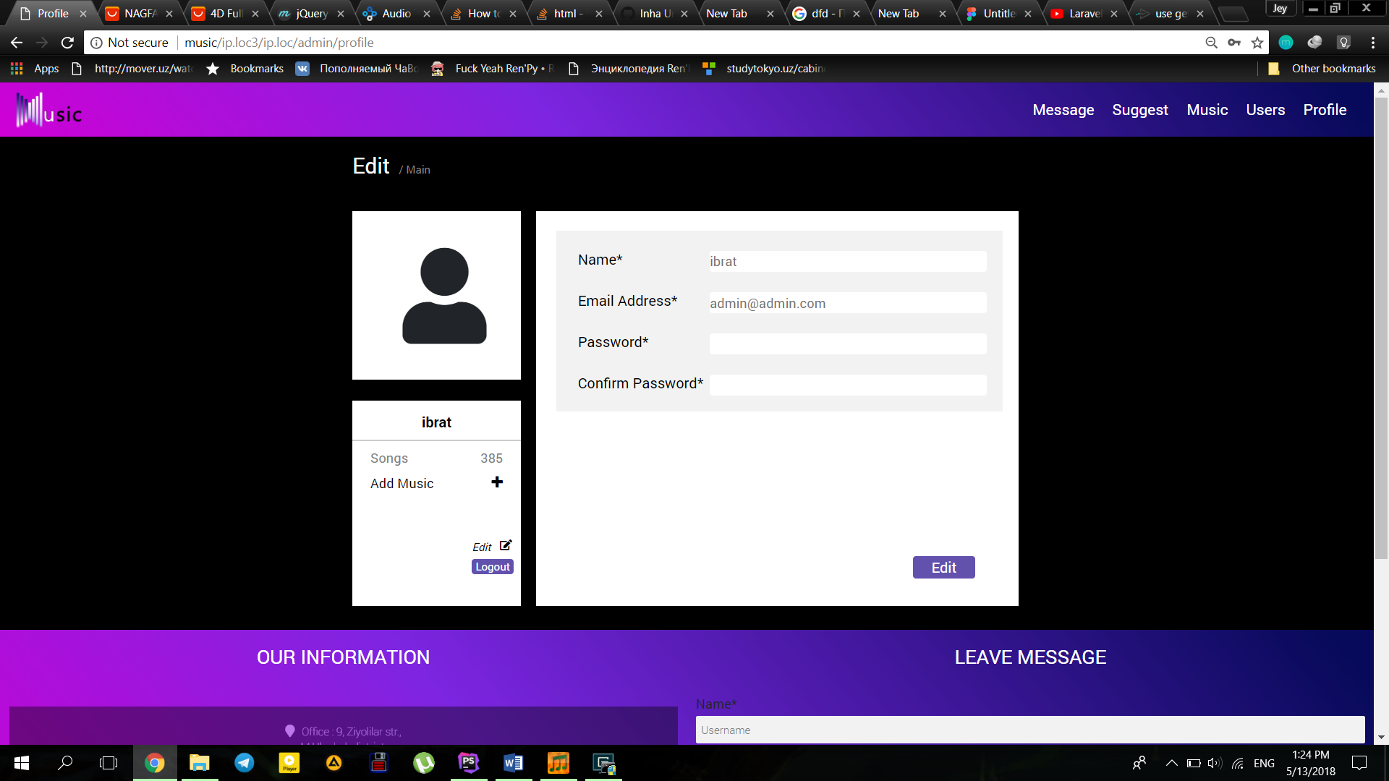

Summary of each member contribution

1. Data about member:

Name: Mokhlaroyim Tuychibaeva

ID: U1610148

Contribution:

Designer & Front-end developer: Whole design of the site and the front end of the index page.

1. Data about member:

Name: Anora Kosimova

ID: U1610120

Contribution:

Front-end developer: About and genres page, with all media and etc.

1. Data about member:

Name: Ibrat Abidov

ID: U1610075

Contribution:

Back-end developer: Backend for admin panel, genre and playlist page.

1. Data about member:

Name: Ilkhom Rakhimov

ID: U1610078

Contribution:

Back-end developer: Backend for index page and for mail.

1. Data about member:

Name: Jamoliddinkhuja Odilkhujaev

ID: U1610092

Contribution:

Back-end & Front-end developer: Backend and front-end for profile page and front-end for playlist page.